Ibrahim Gunsever The Grep Family Lab

**Just as a heads up since I am redoing this lab after already doing the other labs I created a copy of the original datebook file called datebook.bak. Hence why my screenshots mention that. Ive made some changes to the original file and deleted some lines.**

1. Print all lines containing the string San .

grep -wi san datebook

If you wanted to show the line numbers as well it would be grep -wib san datebook



1. Print all lines where the person's first name starts with J .

grep ^J datebook

This tells grep to match all lines that start with the letter j.

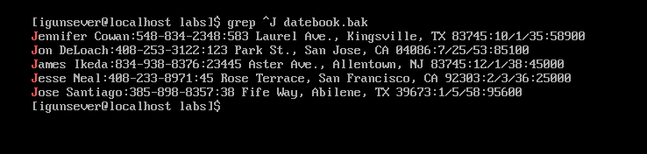

1. Print all lines ending in 700 .

grep $*700 datebook

The dollar sign tells grep to look at the end of the line. In this case showing all the lines that end in 700

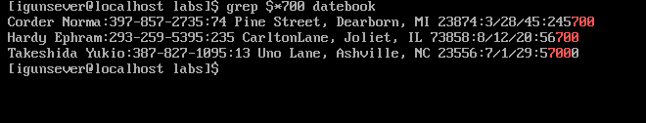

1. Print all lines that don't contain 834 .

grep -v ‘834’ datebook

The -v tells grep what we don’t want to match. So in this case it tells grep to show all lines that DON’T contain 834.

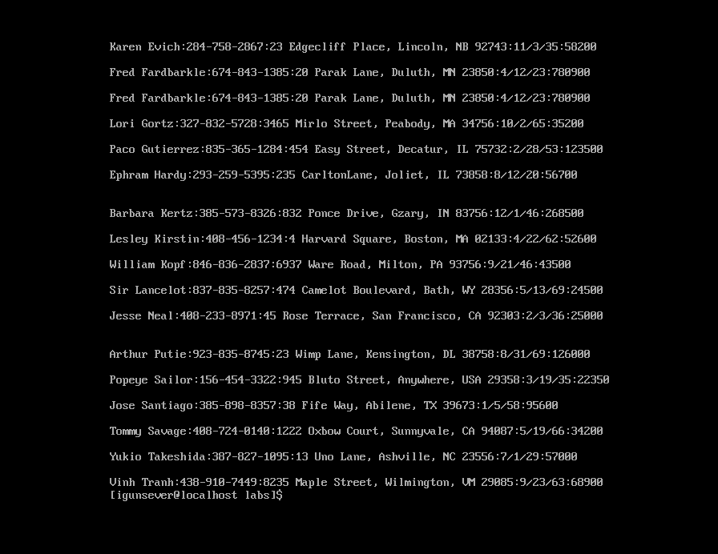

1. Print all lines where birthdays are in December .

grep -E ‘:12/’ datebook.

This is telling grep to only show text that has :12/ in the beginning. In this case that means December.

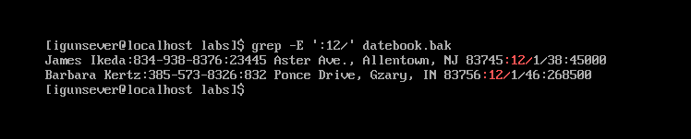

1. Print all lines where the phone number is in the 408 area code.

grep -E ‘:408’ datebook

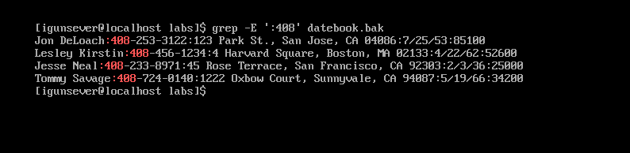

This tells grep to show the lines where ‘:408’ is present. In this case it allows me to see the 408 phone number.

1. Print all lines containing an uppercase letter, followed by four lowercase letters , a comma, a space, and one uppercase letter.

grep ‘[A-Z][a-z]\{4\}, [A-Z]’ datebook

This was a tricky one but essentially [A-Z] tells grep to look for any uppercase letter. [a-z] tells grep to look for any lowercase letter but \{4\} tells grep to look for 4 lowercase letters specifically. The , tells grep to look for a comma and the space tells grep to find a space. Finally the last [A-Z] tells grep to find a uppercase letter at the end.

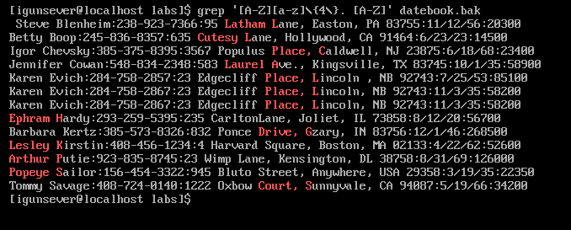

1. Print lines where the last name begins with K or k .

grep -E ‘\<.*\>[ ]\<(K|k)’ datebook

In this instance this command is telling grep that the first name can be any letters but the last name must start with a uppercase or lowercase k. The empty brackets symbolize the space that is between the first and last names.

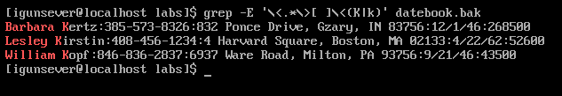

1. Print lines preceded by a line number where the salary is a six-figure number.

grep ‘[0-9]\{6\}$’ datebook

This tells grep to search for any number that is 6 digits in length. The $ tells grep to search for this info at the end of the line.

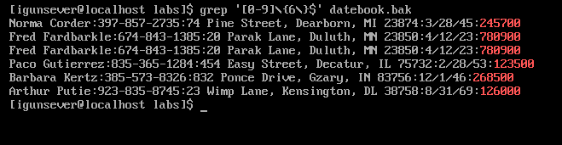

1. Print lines containing Lincoln or lincoln (remember that grep is insensitive to case).

grep -E ‘(L|l)incoln’ datebook

This command tells grep to show all lines that have a uppercase or lower case l followed by the string incoln.

